CLOUD GPU COMPUTE JOB SCHEDULING SYSTEM
CSA0201 – C Programming
KEERTHAN M | Register No.: 1925260006

A. Student Work

1. Problem Understanding and Formulation
The problem is to design a menu-driven C application for managing GPU compute-job requests in a university AI research laboratory. The laboratory has a limited number of shared GPU nodes, so requests from different research groups must be checked before they are scheduled. The system replaces informal and conflict-prone requests with a structured process for recording, validating, searching, sorting, analysing and storing jobs.
• What is the problem? Manage shared GPU compute jobs and ensure that a requested job is not scheduled when its GPU-hour or VRAM requirement exceeds the selected node's available capacity.
• What are the expected outcomes? A working C program that adds and updates jobs, displays records, searches by Job ID, sorts jobs by priority, checks node capacity, analyses utilization, generates a scheduling report and preserves records using files.
• What information/data is available? Job ID, job name, priority, GPU hours, required VRAM, research-group ID/name/leader, selected GPU node and job status. Each node also has an ID, name, VRAM capacity, total hours and allocated hours.
• What assumptions are made? Five predefined GPU nodes are available; each job uses one selected node; priority is between 1 and 10; Job IDs are generated automatically; pending jobs consume GPU-hour capacity; completed jobs release their allocated hours.
• What constraints must be satisfied? Required VRAM must not exceed node VRAM, requested GPU hours must not exceed remaining node hours, Job IDs must remain unique, job records must stay within the maximum array size, and saved records must be retrievable after restart.

2. Application of Course Knowledge
The implementation applies the C programming concepts required by the assignment and combines them into a modular resource-management application.
• Principles: Structured programming, modularity, input validation, resource allocation, data organization and persistent storage.
• Theories: Array-based record processing, linear search, comparison-based sorting, structure composition and sequential file storage.
• Mathematical models: Remaining Hours = Total Hours − Allocated Hours. Utilization (%) = (Allocated Hours / Total Hours) × 100. A job is accepted when Required VRAM ≤ Node VRAM and GPU Hours ≤ Remaining Hours.
• Algorithms: Linear search is used for Job ID lookup. Bubble sort is used to arrange jobs in descending priority. Loops scan job and node arrays.
• Engineering concepts: Capacity planning, resource allocation, utilization monitoring, validation, error prevention and decision support.
• Scientific concepts: GPU utilization is represented quantitatively using resource hours and percentage utilization.
• Design methodologies: The system follows an input → validation → scheduling → analysis → storage/reporting workflow, with functions responsible for separate tasks.
Storage-class justification: The Job Counter is declared as a static local variable inside generateJobId(). Its value persists between function calls. If an automatic local counter were used, it would be recreated on each call and could reset, causing repeated Job IDs. The program also synchronizes the counter after loading saved records.
Observed calculation for GPU Node 1:
Total Hours = 100
Allocated Hours = 100
Remaining Hours = 100 - 100 = 0 hours
Utilization = (100 / 100) × 100 = 100%
Classification = Fully Booked
Observed capacity-check calculation for GPU Node 2:
Node 2 Total Hours = 120
Node 2 Allocated Hours = 0
Requested GPU Hours = 100
Node 2 VRAM = 32 GB
Required VRAM = 24 GB
100 <= 120 → valid GPU-hour capacity
24 <= 32 → valid VRAM capacity
Result = CAPACITY CHECK PASSED

3. Solution / Design / Methodology
The proposed system represents the real-world entities using structures. GPUNode stores node-level resources and ResearchGroup stores group information. Job is the main structure and contains ResearchGroup and GPUNode as nested structures. Arrays of jobs and nodes are created inside main() and passed to user-defined functions through pointers; no global variables are required.
• Design: struct Job contains jobId, jobName, priority, gpuHours, requiredVRAM, nested ResearchGroup, nested GPUNode and status.
• Algorithm: Generate Job ID → collect input → validate priority and resource values → select node → check VRAM and remaining hours → accept or reject → update node allocation.
• Architecture: Menu/interface → processing functions → job/node arrays → file storage → analysis and report generation.
• Process: Initialize nodes, load previous jobs, rebuild allocations, display menu, execute the selected operation, save records and exit.
• Prototype: The console program is a prototype for a university GPU-resource scheduling system.
Major functions and their roles:
Function | Purpose
initializeNodes() | Initializes five GPU nodes and their capacities.
generateJobId() | Generates sequential IDs using a static counter.
addJob() | Collects job/group/node data and validates the request.
checkCapacity() | Checks VRAM and remaining GPU-hour capacity.
searchJob() | Performs linear search by Job ID.
sortJobsByPriority() | Bubble-sorts jobs in descending priority.
updateJob() | Updates priority, GPU hours, VRAM or status.
analyseNodeUtilization() | Calculates utilization and node classification.
saveJobs() / loadJobs() | Stores and retrieves job records using jobs.dat.
generateSchedulingReport() | Creates scheduling_report.txt with utilization and priority information.

System flowchart:
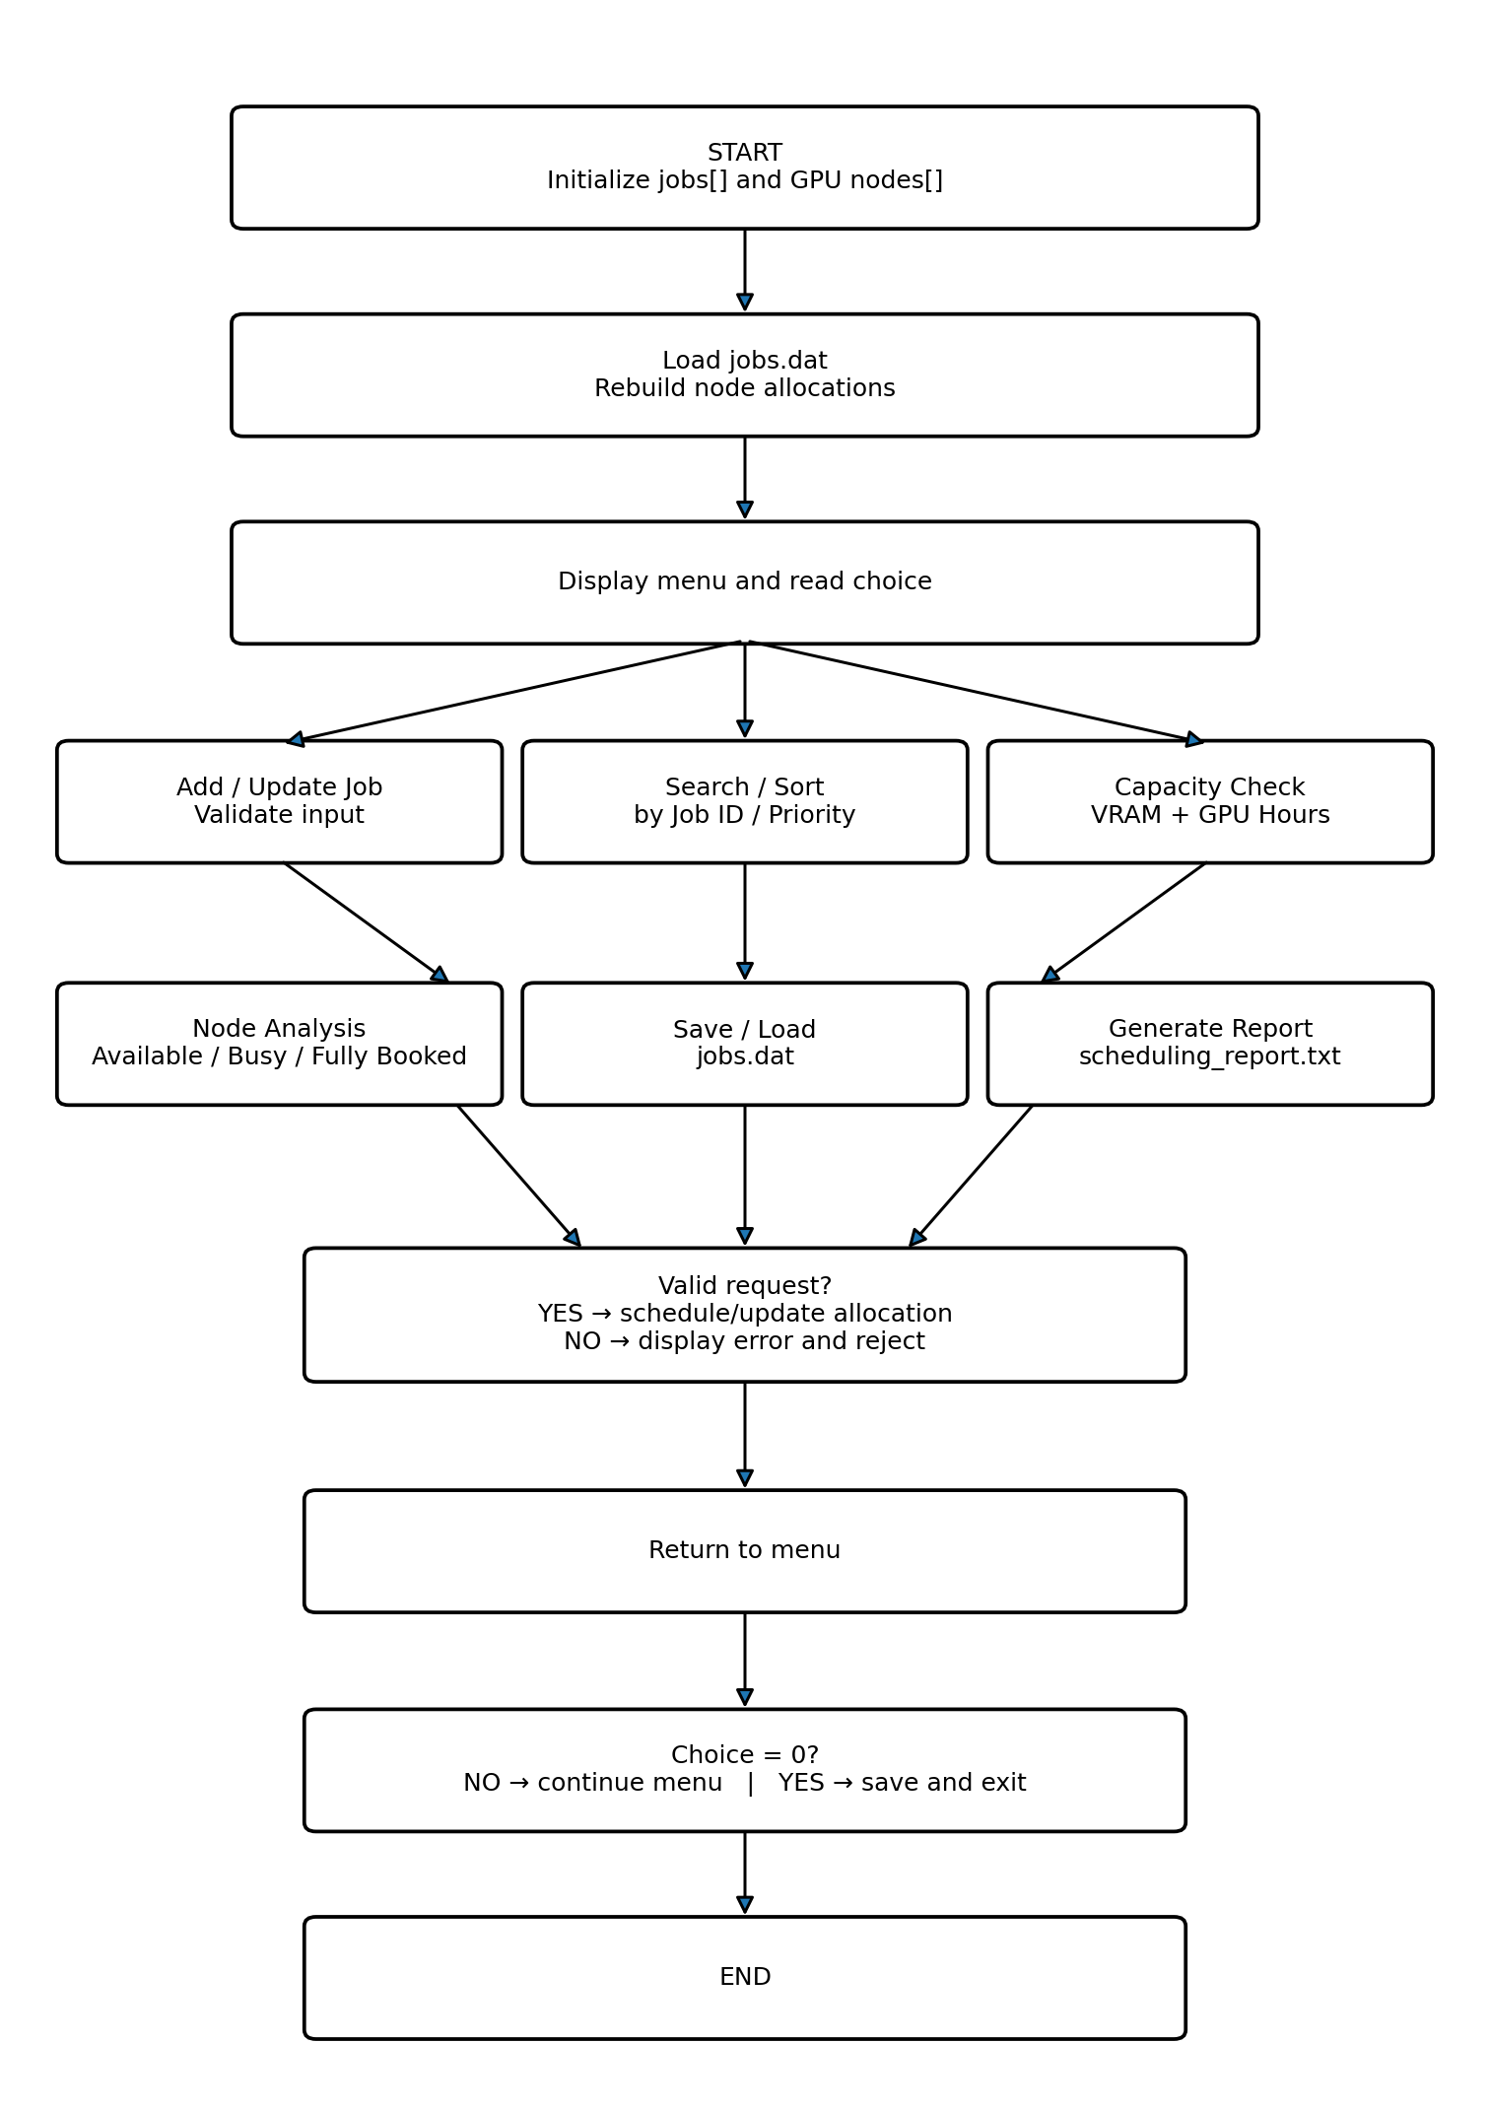
Figure 1. Flowchart of the implemented Cloud GPU Compute Job Scheduling System
Complete pseudocode for the implemented program:
BEGIN
1. Define constants MAX_JOBS = 100 and MAX_NODES = 5.
2. Define GPUNode structure:
nodeId
nodeName
vramGB
totalHours
allocatedHours
3. Define ResearchGroup structure:
groupId
groupName
leaderName
4. Define Job structure:
jobId
jobName
priority
gpuHours
requiredVRAM
group as ResearchGroup
node as GPUNode
status
5. Define all required user-defined functions.
6. MAIN:
Create jobs[MAX_JOBS].
Create nodes[MAX_NODES].
Set jobCount = 0.
Set nodeCount = 0.
7. Call initializeNodes(nodes, &nodeCount).
8. Call loadJobs(jobs, &jobCount).
9. Call rebuildNodeAllocation(jobs, jobCount, nodes, nodeCount).
10. REPEAT until choice = 0:
Display the menu.
Read choice.
IF choice = 1 THEN
Call addJob().
Check whether jobCount reached MAX_JOBS.
Generate a new Job ID using static jobCounter.
Read job name.
Read priority.
Repeat until priority is between 1 and 10.
Read GPU hours.
Repeat until GPU hours are positive.
Read required VRAM.
Repeat until VRAM is positive.
Read research-group ID, name and leader.
Display available GPU nodes.
Read selected node ID.
Search the node array.
IF node ID is invalid:
Display error.
Reject request.
ELSE:
Copy selected node into the Job structure.
Set job status to Pending.
Call checkCapacity().
IF required VRAM exceeds node VRAM:
Display VRAM error.
Reject job.
ELSE IF GPU hours exceed remaining node hours:
Display GPU-hour capacity error.
Reject job.
ELSE:
Store job in jobs array.
Increase node allocated hours.
Update nested node details in the job.
Increment jobCount.
Display success message.
ELSE IF choice = 2 THEN
Read Job ID.
Search using linear search.
IF job is not found:
Display error.
ELSE:
Display update menu.
IF priority selected:
Read and validate new priority.
Update priority.
ELSE IF GPU hours selected:
Temporarily remove old allocation.
Validate new hours against node capacity.
If invalid, restore old allocation.
Otherwise update hours and allocation.
ELSE IF VRAM selected:
Validate new VRAM against node capacity.
Update VRAM.
ELSE IF status selected:
Read Pending or Completed.
When changing Pending to Completed,
release the job's allocated hours.
When changing Completed to Pending,
check capacity before reallocating hours.
ELSE IF priority and status selected:
Validate and update both values.
ELSE IF choice = 3 THEN
IF jobCount = 0:
Display no-record message.
ELSE:
Traverse jobs array using a loop.
Display all jobs.
ELSE IF choice = 4 THEN
Read Job ID.
Call searchJob().
IF returned index = -1:
Display Job ID not found.
ELSE:
Display complete Job, ResearchGroup and GPUNode details.
ELSE IF choice = 5 THEN
IF no jobs exist:
Display no-job message.
ELSE:
Perform bubble sort.
Compare adjacent priorities.
IF left priority < right priority:
Swap the two Job structures.
Continue until descending priority order is obtained.
Display sorted jobs.
ELSE IF choice = 6 THEN
Read Node ID.
Search the node array.
IF node not found:
Display error.
ELSE:
Read requested GPU hours and required VRAM.
Calculate remaining hours.
IF required VRAM > node VRAM:
Display capacity failure.
ELSE IF requested GPU hours > remaining hours:
Display capacity failure.
ELSE:
Display capacity check passed.
ELSE IF choice = 7 THEN
FOR every GPU node:
Calculate utilization percentage.
IF utilization <= 0:
Classification = Available.
ELSE IF utilization < 100:
Classification = Busy.
ELSE:
Classification = Fully Booked.
IF utilization >= 80 and < 100:
Display nearing-full warning.
ELSE IF choice = 8 THEN
Open scheduling_report.txt for writing.
IF file cannot be opened:
Display file error.
ELSE:
Write pending high-priority jobs.
Calculate total available hours.
Calculate total allocated hours.
Calculate remaining hours.
Write each node's utilization and status.
Flag nodes nearing full utilization.
Close report file.
Display report-generated message.
ELSE IF choice = 9 THEN
Open jobs.dat in binary write mode.
Write jobCount.
Write all Job structures.
Close file.
Display save-success message.
ELSE IF choice = 10 THEN
Open jobs.dat in binary read mode.
IF file does not exist:
Start with an empty job list.
ELSE:
Read jobCount.
Read saved Job structures.
Find the largest Job ID.
Synchronize the static Job Counter.
Close file.
Rebuild node allocations.
ELSE IF choice = 11 THEN
Display all GPU node details.
ELSE IF choice = 0 THEN
Save current job records.
Display exit message.
ELSE
Display invalid menu-choice message.
11. UNTIL choice = 0.
12. RETURN 0.
END

4. Use of Modern Tools
The implementation is a C console application developed and tested using a C programming compiler/development environment. The supplied output document provides evidence of actual execution of the implemented menu and functions.
• C compiler / IDE: Used to compile and execute the C source file and verify the menu-driven workflow.
• C standard libraries: stdio.h supports console input/output and file handling; string.h supports string operations; stdlib.h provides standard C support.
• File system: jobs.dat is used for persistent binary job records and scheduling_report.txt is used for the generated report.
• GitHub: The source file can be uploaded to a GitHub repository as the assignment requires a GitHub upload.
Tool/output evidence is presented in Section 5 using the supplied execution screenshots.

5. Results and Validation
The uploaded output document contains six pages of console evidence. The observed execution covers the main menu, adding a job, updating it, displaying it, searching, sorting, capacity checking, node utilization analysis, report generation, saving, loading and node display.
No. | Feature | Observed Input / Condition | Observed Result | Status
1 | Main menu | Menu options 1–11 and Exit displayed | Menu displayed successfully | Pass
2 | Add New Job | Job 1002; ai research; priority 8; 100 GPU hours; 24 GB VRAM; Node 1 | Job added successfully | Pass
3 | Update Job | Job 1002 priority changed from 8 to 9 | Priority updated successfully | Pass
4 | Display Jobs | Job 1002 shown with priority 9 and Pending status | Record displayed | Pass
5 | Search by ID | Search for Job 1002 | JOB FOUND with group and node details | Pass
6 | Priority Sort | Job 1002 priority = 9 | Sorted successfully in descending order | Pass
7 | Capacity Check | Node 2; request 100 hours and 24 GB VRAM | CAPACITY CHECK: PASSED | Pass
8 | Utilization Analysis | Node 1 allocated 100 of 100 hours | 100% utilization; Fully Booked | Pass
9 | Generate Report | Menu option 8 | scheduling_report.txt generated | Pass
10 | Save File | Menu option 9 | jobs.dat saved successfully | Pass
11 | Load File | Menu option 10 | 1 previous record loaded | Pass
12 | GPU Node Display | Menu option 11 | Node 1 shows 100 allocated hours | Pass

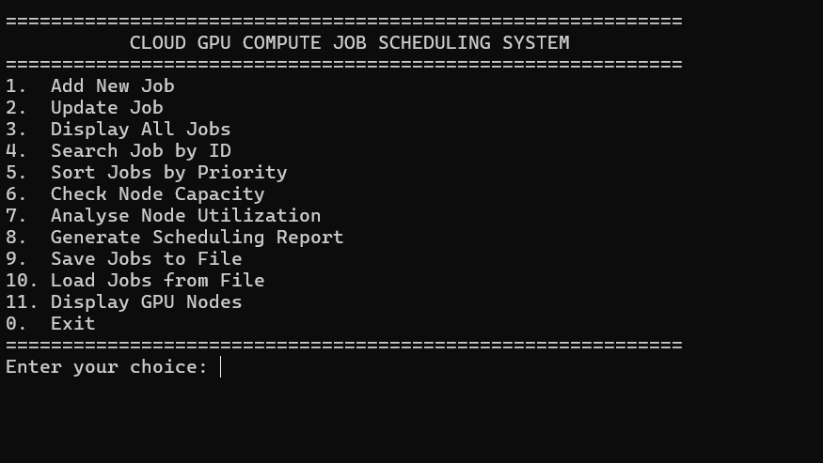
Figure 2. Main menu of the Cloud GPU Compute Job Scheduling System
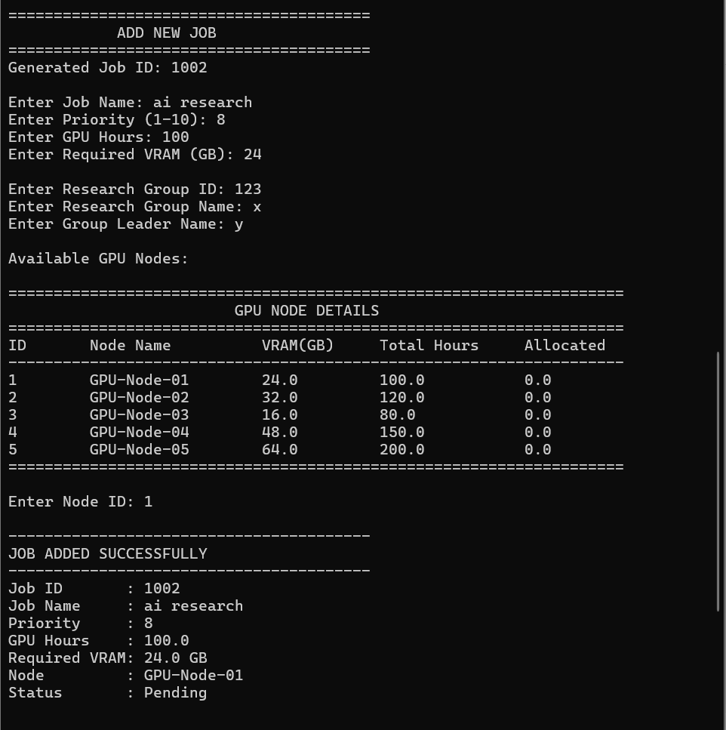
Figure 3. Adding a new GPU job
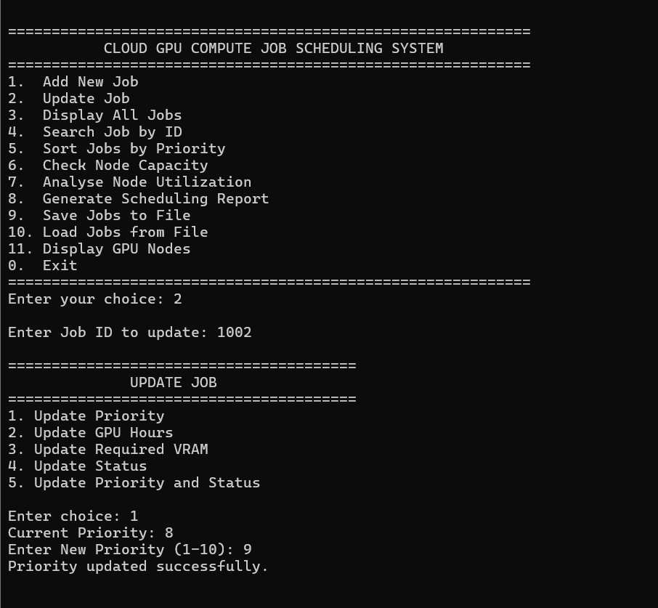
Figure 4. Updating Job 1002 priority from 8 to 9
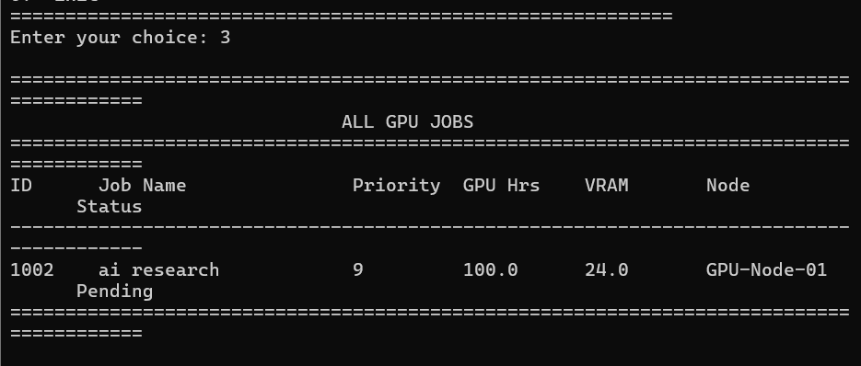
Figure 5. Displaying all GPU jobs
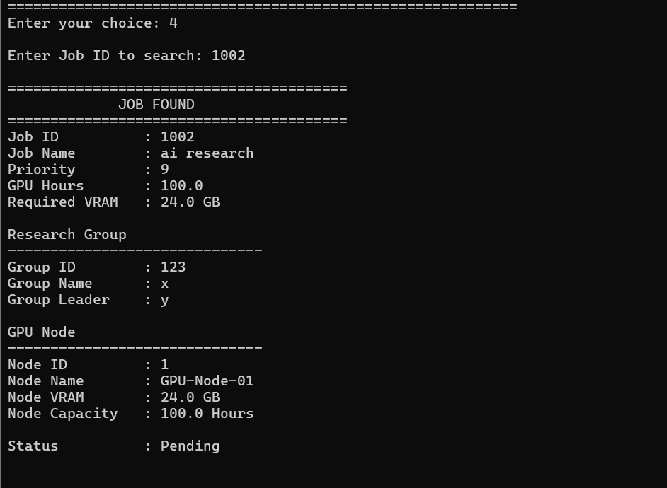
Figure 6. Searching for Job ID 1002
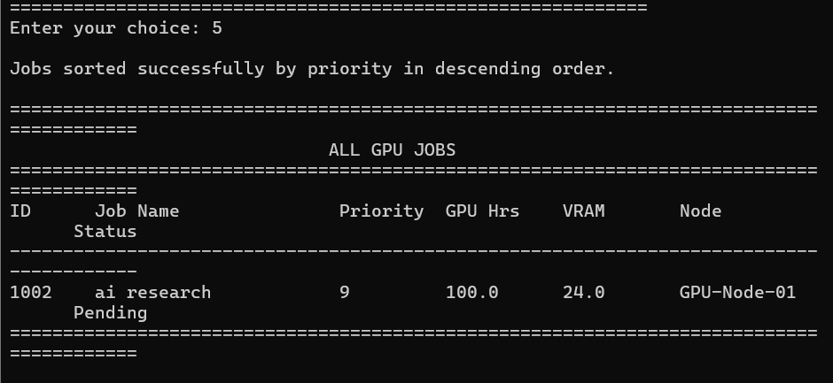
Figure 7. Sorting jobs by priority in descending order
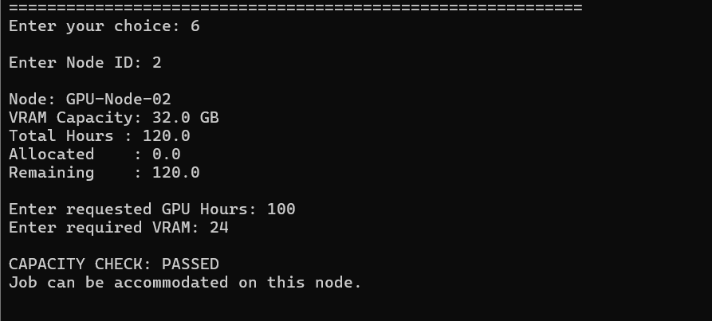
Figure 8. Successful capacity check on GPU Node 2
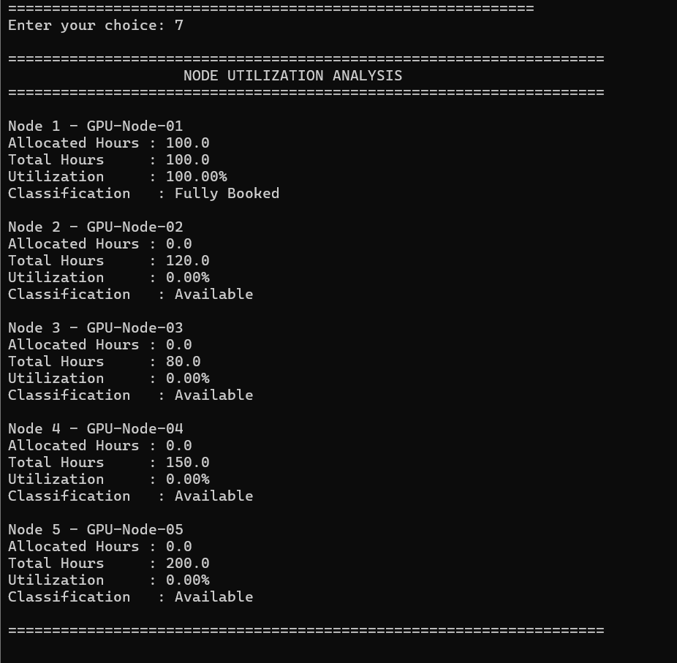
Figure 9. GPU-node utilization analysis
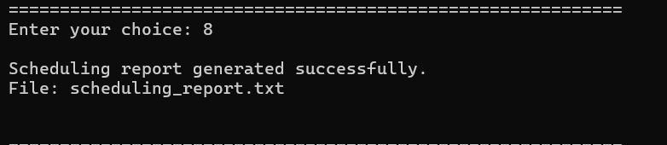
Figure 10. Scheduling report generation
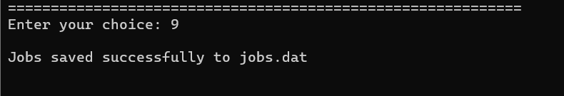
Figure 11. Saving job records to jobs.dat
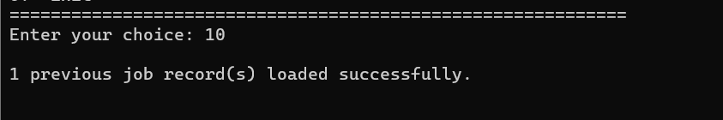
Figure 12. Loading a previously saved job record
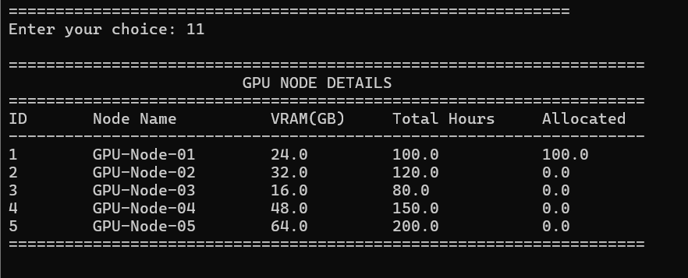
Figure 13. Displaying GPU-node details
Validation against the stated requirements:
• Menu-driven functionality: The supplied output shows the numbered menu and successful execution of the required operations.
• Structures and nested structures: The Job Found output displays Research Group and GPU Node information within the job record.
• Searching: Job ID 1002 was successfully found using the search operation.
• Sorting: The program reports successful descending priority sorting.
• Capacity validation: Node 2 accepted 100 requested GPU hours because 100 is within its 120-hour capacity, and 24 GB VRAM is within its 32 GB capacity.
• Utilization analysis: Node 1 is shown at 100% utilization and classified as Fully Booked; unused nodes are classified as Available.
• File handling: The report was generated, job records were saved to jobs.dat, and one previous record was loaded.
• Persistence: The successful load operation demonstrates retrieval of a previously saved job record.

6. Analysis and Engineering Decision
The observed results indicate that the selected design is suitable for a small university GPU laboratory. The system models the main entities with nested structures, separates operations into functions, checks resource limits before scheduling, and stores records for later retrieval.
• Alternative 1 – Separate parallel arrays: This is simple but can lead to mismatched fields and does not model the relationship between a job, group and node as clearly.
• Alternative 2 – Nested structures with arrays: This is the selected solution. It keeps related data together, directly demonstrates the required C structure concepts and remains easy to search and sort.
• Alternative 3 – Linked-list based records: A linked list could grow dynamically but would add pointer-management complexity. The fixed array approach is adequate for the assignment's defined record limit.
• Advantages: Simple menu-driven operation, clear resource validation, modular functions, searching, sorting, utilization analysis, report generation and persistent storage.
• Limitations: The current prototype has a fixed maximum of 100 jobs and five predefined nodes. It does not use real-time GPU sensors, multi-user networking, authentication or a database.
• Trade-offs: Fixed arrays give predictable memory use and simple indexing, while dynamic structures would offer greater scalability. The array approach was selected because it is easier to implement, test and explain for this C programming assignment.
• Final engineering decision: The nested-structure, array-based and function-oriented design was selected because it satisfies the required C concepts while providing a clear and testable GPU scheduling workflow.

7. Broader Considerations
• Sustainability: Tracking allocation and utilization helps reduce unnecessary idle or over-allocated GPU resources.
• Environment: Better utilization can reduce wasted computation and associated energy consumption.
• Society: A defined scheduling process can reduce conflicts between student research groups sharing the same laboratory resources.
• Safety: Capacity and VRAM validation prevents software-level over-allocation beyond configured node limits.
• Ethics: Explicit scheduling rules provide a transparent basis for allocating shared resources.
• Economics: Efficient use of expensive GPU infrastructure can improve the value obtained from available computing resources.
• Accessibility: The numbered console menu provides a straightforward interface for administrators.
• Professional responsibility: The system validates input, handles errors, preserves records and makes resource decisions using explicit rules.

8. Conclusion
• Proposed solution: A modular C-based Cloud GPU Compute Job Scheduling System was developed to manage job requests against limited GPU-node resources.
• Major findings: The supplied execution successfully demonstrated adding, updating, displaying, searching, sorting, capacity checking, utilization analysis, report generation, saving and loading.
• Achievement of requirements: The implementation uses arrays, strings, structures, nested structures, decision-making, loops, searching, sorting, functions, pointers, static storage and file handling.
• Limitations: The current system uses predefined nodes and a fixed job-array size and is not connected to physical GPU monitoring.
• Possible improvements: Future work could introduce dynamic memory allocation, real-time GPU metrics, database storage, authentication, advanced scheduling policies and a graphical/web interface.

9. Student Reflection
• What did I learn from this assignment beyond what was directly taught in the classroom? I learned how individual C concepts can be combined into a complete application. The project improved my understanding of nested structures, pointers to structures, modular functions, file persistence, sorting and validation. I also learned that resource allocation must be checked before modifying the stored state of a system.
• If I were given additional time/resources, what would I improve and why? I would introduce dynamically allocated records, database storage and real-time GPU monitoring. I would also add authentication and a web-based interface so that multiple research groups could submit and track requests. These changes would make the prototype more scalable and closer to a real scheduling platform.

10. References
1. Department of Computer Science and Engineering, CSA0201 – C Programming Assignment Questions, “Designing a Cloud GPU Compute Job Scheduling System.”
2. Department of Computer Science and Engineering, Assignment Format, A. Student Work, Sections 1–10.
3. C Standard Library documentation for stdio.h, stdlib.h and string.h, used for standard input/output, file handling and string processing.
4. GitHub documentation, used as the intended platform for source-code upload and version control.
5. AI-assisted development support was used to help structure and explain the C implementation; the final implementation was compiled and validated through the recorded console execution.

